Airport Network

**Abstract**

The purpose of the project is to analyze the connectivity of different airports in USA and how important are they in US airport network within and the overall world. For our analysis we used the data from US Bureau of Transportation Statistics from Jan 2017 to May 2017 this dataset contains all flight routes. We used various network measures like Centrality, Hub-Scores, Authority-Scores, PageRank to predict the importance of the Airports in US domestic airport network. Also tried to measure impact on other airports if some major airports were happened to shut down for some reason like terrorist threats, bad weather or worker strikes. Finally, we also have some not so prominent airports being the key to attain a structural balance in the US Airport networks.

**Introduction**

Number of airline passengers are increasing YOY drastically. In 2016, there are 823 million passengers is an all-time high with 719.0M Domestic travelers and 103.9M International travelers. Out of these 85% of the airline passengers travel through approximately 10% of the airports.

**Passengers vs Number of Airports**

## https://lh6.googleusercontent.com/VIjI4UGEyR3KiFkpOUjqWG6YFcNNi6etfXXXdAr6nP9hiVAxF9VIwHeTA1mW6jm82EF2izTjh27rGIJ5r9EoYhKByxBp1evB3C-Es6KNfeuqmXKA6gqN4rxrCutWxhfyBUJ0I_4uThis gives us the base that there are some airports that needs to have high attention based on the current increase in the airline travelers. We wanted to test is the number of passengers traveling is the only measure to know the importance of an Airport or should we also check into other facts like how connected is the airport with other domestic or international airports. We started exploring data and found some interesting facts that are presented in this report.

**Figure-1**

**Data**

The Airport data is taken from US Bureau of transportation statistics from Jan’2017 to May’2017. The data consists of 4 main variables with 1,586 nodes and 28,339.

1.      Origin Airport(Origin)

2.      Destination Airport(Destination)

3.      Number of Passengers(no_pasg)

4.      Distance Between Airports(Distance)

The data contains all the flight routes between 2 airports. Each Airport is a node and the edge starts from the origin airport and ends at destination airport. The edges here represent the flight routes from origin airport to destination airport. The edges are weighted edges and weights are based on number of passengers traveling in that route. Thickness of the Edge depends on the number times Edge distance is proportional to the distance between 2 airports

**Network of All Routes from US and to US Airports**

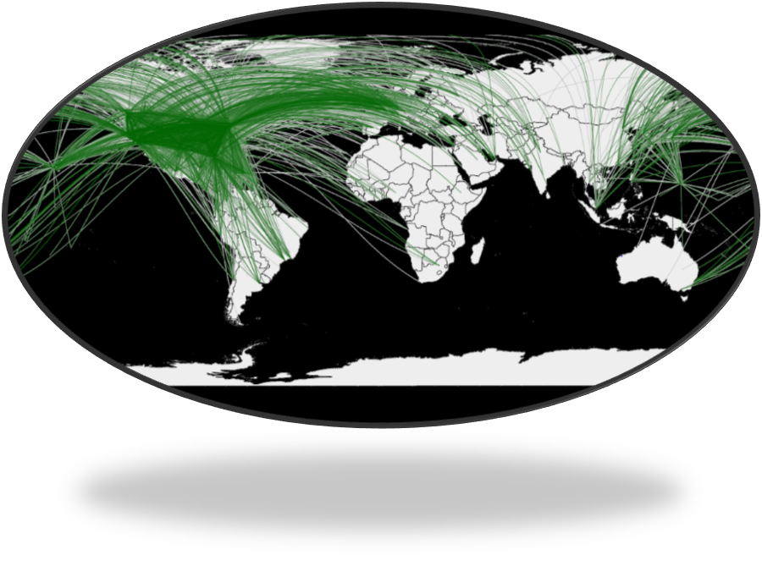

**Figure-2**

Here we mapped the latitude, longitude for each airport in a world map using R. So that we can visualize the airports and the number of routes from each airport. We can see in the network that there are 4 to 5 airports in the network that have many links when compared to other airports. Atlanta, Chicago, New York, Denver are the airports that have high number of flights. Brazil, United Kingdom & East China are highly traveled by Americans. We also believed that the major catastrophe to the airports in major cities would lead to a huge damage in Airport Networks. We plan to test on this belief using network measures like hub-score, Authority-score, betweenness centrality etc.

**Betweenness Centrality**



**Figure-3**

|  |  |  |
| --- | --- | --- |
| Top 5 Betweenness Centrality Airports | | |
| Rank | **Airport** | **Score** |
| 1 | Ted Stevens-Alaska | 0.3538 |
| 2 | Seattle-Washington | 0.0873 |
| 3 | Denver-Colorado | 0.0757 |
| 4 | Fairbanks-Alaska | 0.0684 |
| 5 | Minneapolis-Minnesota | 0.0456 |

**Table-1**

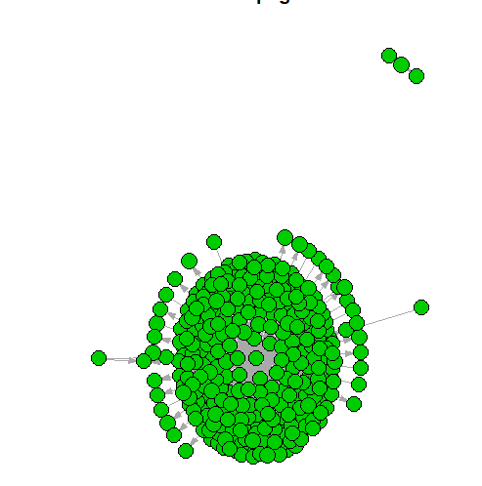

**Figure-4**

**Closeness Centrality**

|  |  |  |
| --- | --- | --- |
| Top 5 Closeness Centrality | | |
| Rank | **Airport** | **Score** |
| 1 | Denver-Colorado | 0.4848 |
| 2 | Ted Stevens-Alaska | 0.4838 |
| 3 | Memphis-Tennessee | 0.4815 |
| 4 | Minneapolis-Minnesota | 0.4813 |
| 5 | Hartsfield-Jackson-Georgia | 0.4806 |

**Table-2**

**Hub-Scores**

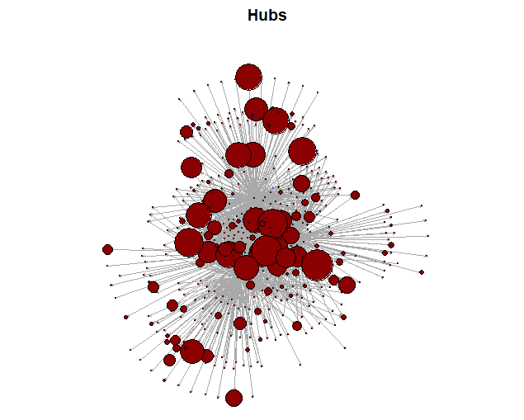

**Figure-5**

|  |  |  |
| --- | --- | --- |
| Top 5 Airports Hub-Score | | |
| Rank | **Airport** | **Score** |
| 1 | O’Hare International-Illinois | 0.0237 |
| 2 | Hartsfield-Jackson-Georgia | 0.0201 |
| 3 | Denver-Colorado | 0.0196 |
| 4 | Philadelphia -Pennsylvania | 0.0178 |
| 5 | Detroit Metro-Michigan | 0.0171 |

**Table-3**



**Table-4**

**Figure-6**

**Authority-Scores**

|  |  |  |
| --- | --- | --- |
| Top 5 Airports based on Authority-Score | | |
| Rank | **Airport** | **Score** |
| 1 | O’Hare International-Illinois | 0.0235 |
| 2 | Hartsfield-Jackson-Georgia | 0.0209 |
| 3 | Denver-Colorado | 0.0193 |
| 4 | Philadelphia-Pennsylvania | 0.0184 |
| 5 | Charlotte-North Carolina | 0.0172 |

**PageRank**



**Figure-7**

|  |  |  |
| --- | --- | --- |
| **Top 5 PageRank Airports** | | |
| Rank | **Airport** | **Score** |
| 1 | Denver-Colorado | 0.0174 |
| 2 | Ted Stevens-Alaska | 0.0169 |
| 3 | O’Hare International-Illinois | 0.0151 |
| 4 | Hartsfield-Jackson-Georgia | 0.0147 |
| 5 | Minneapolis-Minnesota | 0.0129 |

**Table-5**